Monster’s Inc.

Maintenance Plan

Roomie

# Operations and Maintenance Plan for Roomie

# Purpose

The purpose of this Operations and Maintenance Plan is to draw out the necessary stages of continuing support for the iOS application, Roomie, and its software. It is also responsible for identifying who will be taking care of which parts of the ongoing maintenance of this app, as well as the budget for maintaining the app for the next year.

## 1.1. Support Objective

The goals of this Operations and Maintenance Plan is to make sure that the iOS application Roomie will be monitored regularly on a 24/7 basis, and that the interruptions that effect the app and its users are reduced when there are new software upgrades to the app.

## 2. Support Strategy and Environment

## Support Strategy

This Operations and Maintenance plan will be in existence for the next year, and succeeding that, a new and revised plan will be released for the following year.

New releases will be available triennially with changes implemented.

* The last Thursday in February
* The last Thursday in June
* The first Thursday in November

This Operations and Maintenance Plan will be in place for the next year. Changes could be made based on the major update releases of the application. A release packet will describe the approved modifications and change proposals. The release packet will also be available on the major release dates.

Multiple changes will be implemented on each major release date.

## 3. Support Responsibilities

## Software Maintenance

The software maintenance for the Roomie application is provided by Monster’s Inc.

Contact Information for Software Maintenance:

softwaremaintenance@monstersinc.com

### System Administration

The systems administration for the software of the Roomie application is provided by Monster’s Inc.

Monster’s Inc. Contact Information for system administration:

systemadministration@monstersinc.com

## 4. Support Process

## If there is an issue with the application or any maintenance requests, a customer can fill out a maintenance request form and send it to the software maintenance contact. Maintenance form attached.

### Problem Referrals

Different types of problem with the system will be taken care of by different centers to make the process quick and easy.

### Escalation Procedures

Maintenance requests submitted before the release date will have priority first come first serve basis. If a request is not fulfilled by the following release date, it will have top priority for the next release date. When customers give new ideas for the application, those will be implemented only after all maintenance requests are filled.

## 5. Support Approach

The Roomie application will be monitored in two ways. There is automated monitoring that notifies the designated contact person if problems are occurring, as well as manual check-ups. Manual check-ups will check some aspects of the system and specific components.

Preventive Controls

Be as efficient as possible during the maintenance fixes to cover as many issues as possible. If more problems are covered during each major release date, the costs will be reduced for the next dates.

The strategy for responding to unplanned incidents that may cause risk to the Roomie application is immediate action. Once the problem arises, the members of Monster’s Inc. will ensure resumption of normal operations as soon as possible.

**COSTS**

In order for Monster’s Inc. to be able to maintain the application as well as make advances, we’re going to need to hire some staff such as an iOS Developer, mobile developer, and data analyst. In order to be able to afford all of those staff members, and make a profit, we will also need to hire a Software sales engineer and marketing specialist. Looking at all these costs, maintaining our project for the next year will cost us almost $700,000. We’d have to start small and pay for things that are absolutely necessary in the beginning.

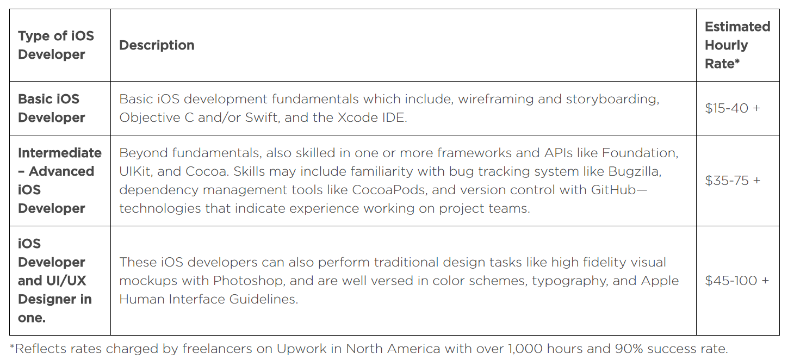

Mobile Developer

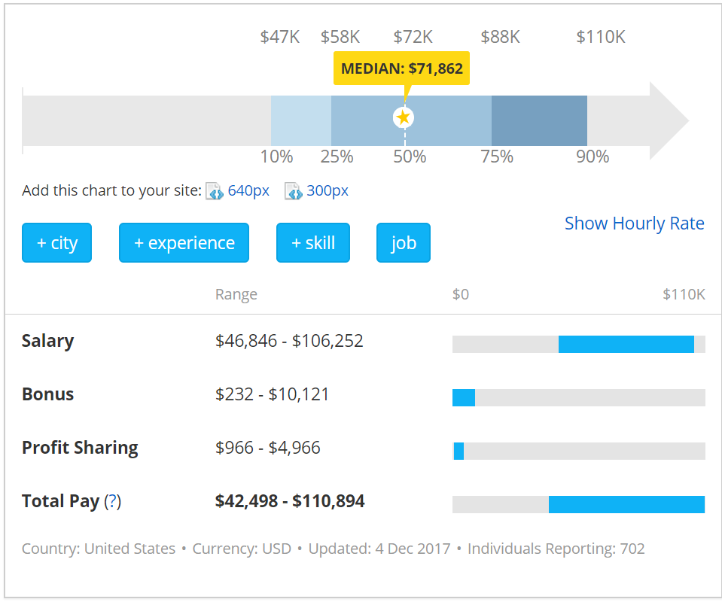

Data Scientist

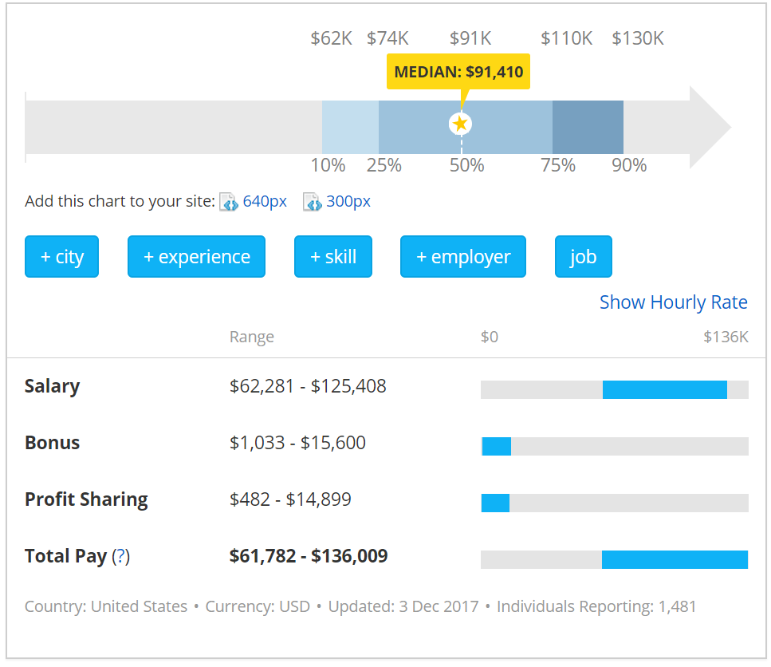

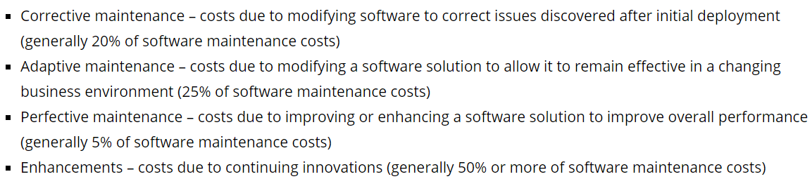

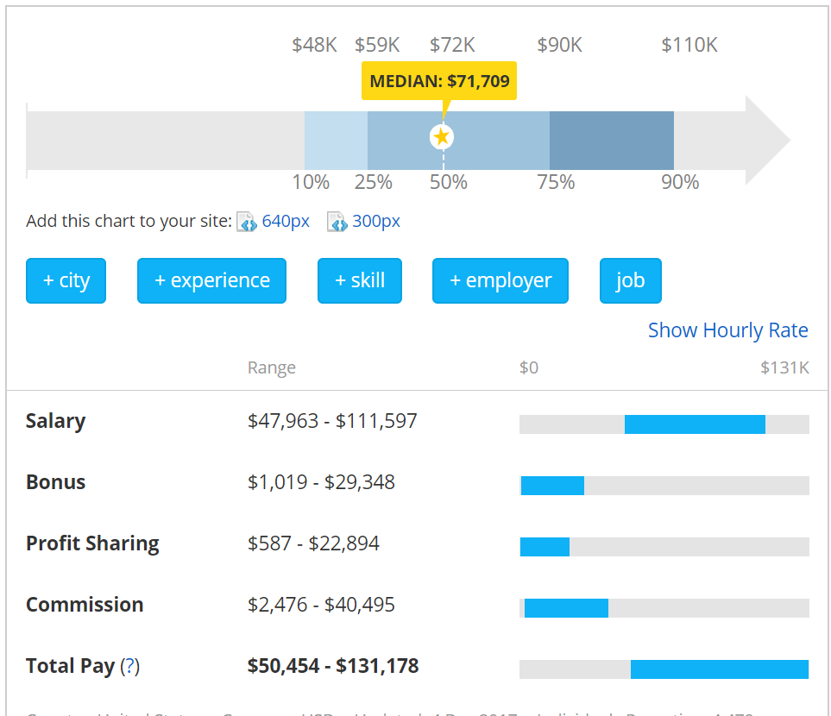Sales Engineer

Marketing Specialist

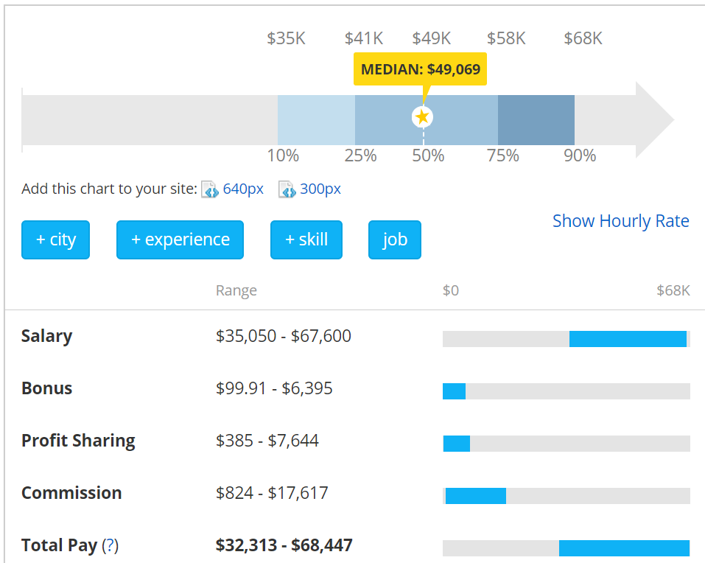

Works Cited

<https://www.payscale.com/research/US/Job=Data_Scientist%2C_IT/Salary>

<https://www.payscale.com/research/US/Job=Mobile_Applications_Developer/Salary>

<https://www.upwork.com/hiring/development/cost-hire-software-developer/>

<http://galorath.com/software_maintenance_cost>

<https://www.payscale.com/research/US/Job=Marketing_Specialist/Salary>

<https://www.payscale.com/research/US/Job=Sales_Engineer/Salary>